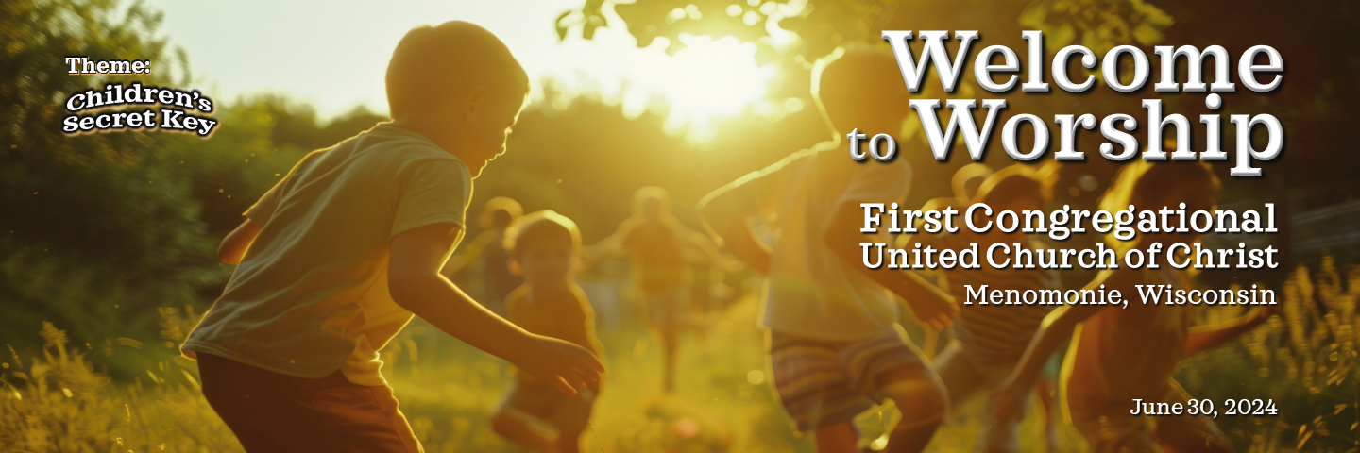

**Welcome and Announcements** Karen Miller

**Prelude/Candle Lighting** “Song Without Words, Op.30, #3” Oxana Khramova  
 (F. Mendelson)

**Ringing of the Bell**

**\*Call to Worship**  Dean Langby

Leader: We are called to remember being a child.

**All: We delight in the child that lives within us.**

Leader: We remember seeing the world through a child’s eyes.

**All: We delight in seeing Creation as if for the first time.**

Leader: We let go of worries and fears.

**All: We play in God’s timeless, beautiful world.**

**\*Opening Prayer** (in unison) Dean Langby **God of new beginnings, we bear scars from the hardships of growing up. We hid the candle of our true selves to keep it burning. Help us to be ourselves in your presence and give us the courage to let others feel safe to show joy, wonder and playfulness around us. Help us to bring the loving, accepting kin-dom of God into our lives.**

**\*Opening Hymn** “Joyful, joyful we adore thee” Hymnal #464

**Readings** Nita Fitzgerald

Mark 10: 13-16

I Corinthians 13: 8-13

Poem by Ryokan, 18th Century Zen Master

**Special Music** “Rondo from 3 Duos” Luke De Moe & Dean Langby

(L. Van Beethoven)

**Sermon** “Children’s Secret Key” Dean Langby

**Transitional Music** “Tell Me the Stories of Jesus” Oxana Khramova  
 (F. Challinor)

**Prayers of the People** Karen Miller

**Lord’s Prayer**

**Our Father/Mother/Creator, who art in heaven, hallowed be thy name. Thy kingdom** **come, thy will be done on earth as it is in heaven. Give us this day our daily** **bread, and forgive us our debts as we forgive our debtors. And lead us not into temptation but deliver us from evil. For thine is the kingdom, and the power, and the glory forever.**

**Offertory** “The Easy Winners” Luke De Moe & Dean Langby

(Scott Joplin, arr. Deborah Kaufmann)

**\*Doxology**

**Praise God from whom all blessings flow;**

**Praise God all creatures here below;**

**Praise God above ye heavenly host;**

**Creator, Christ, and Holy Ghost. Amen.**

**\*Prayer of Dedication** (in unison) Karen Miller

**Oh Dear One, may these scraps of paper and bits of metal serve as symbols of our deep desire for your Love to transform our time, effort, and substance into works of creative compassion for each other, for our wider community, and for the world beyond, through this church. So may it be, Amen.**

**\*Closing Hymn** “How great thou art” Hymnal #467

**\*Benediction** Karen Miller

Leader:

**Remember that faith walks simply and childlike between the darkness of human life and the hope of what is to come. May you be open and attuned to the countless ways that our Creator God comes to us through our senses, through the gifts of creation. May you be like children and step into the gift of the new day, full of hope, promise, and potential. And may the Lord give you the heart of a child and the awesome courage to live it out as an adult.**

**All: Amen.**

**\*Sung Benediction** (unison)

God be with you till we meet again;

By their counsels' guide, uphold you;

With their sheep securely fold you;

God be with you till we meet again.

**Postlude** “Jesus Wants Me for a Sunbeam” Oxana Khramova *The flowers today are from Deb and John Wesolek, Happy Summer!*

**Credits**

* Prayer of Dedication by James Burklo at <https://progressivechristianity.org/resource/prayer-of-dedication-offering/>, August 2014.
* Benediction adapted from “Molchanie: The Silence of God” by Catherine Doherty, 1982.
* Licenses purchased to reprint, podcast, and/or stream the music in this service obtained: ONELICENSE #A-715543. All rights reserved. CCLI Copyright License B 20989858

**This Week**

Church Office is closed on Thursday, July 4 for Independence Day observation.

**Announcements**

**Emergency Contact During our Transition Time:** In between pastors, if you have an emergency needing a hospital visit, end-of-life care, or crisis, Rev David Huber, Plymouth UCC in Eau Claire is on-call for us. The best way to contact him is by calling Plymouth Church, 715 835-5475, where you will reach a person or a message with his emergency #.

**Mission Statement of First Congregational United Church of Christ in Menomonie, WI**

We are called together:

To celebrate God’s presence.

To help each person to grow in his or her relationship with God;

To create a welcoming and supportive community of all God’s people, affirming the diversity of race, gender, age, sexual orientation, gender expression, and identity, social and economic status, and the differently abled;

To observe and share life’s passages and our faith traditions;

To reach out in love seeking justice and peace;

And to tell the old story of Jesus and His love.

**Land Acknowledgement**

Here we congregate on Ojibwe, Dakota, Menominee, Potawatomi, and Ho Chunk land. Generations of Indigenous people occupied and provided careful stewardship of this land long before Europeans arrived on these shores. The traumatic dispossession of this land by European immigrants and the displacement of countless individuals produced collective suffering that has repercussions for our Indigenous neighbors today. The original inhabitants of this land–known to some Indigenous peoples as Turtle Island–took seriously the Creator’s call to be stewards of air, land, water, and creatures. With gratitude, we acknowledge the lessons we continue to learn from our Indigenous neighbors as we seek to be good stewards and pray for guidance in learning how to make reparations.

**ONA Covenant**

We covenant as a congregation to welcome, celebrate, and include lesbian, gay, bisexual,  
transgender, queer, and questioning people and their families into the full life of our church. We take this stance publicly and proudly, knowing that silence is inadequate to confront the violent theology that is widespread throughout the Christian church. We covenant to support lesbian, gay, bisexual, transgender, queer, and questioning people and their families with our prayers, words, and actions.