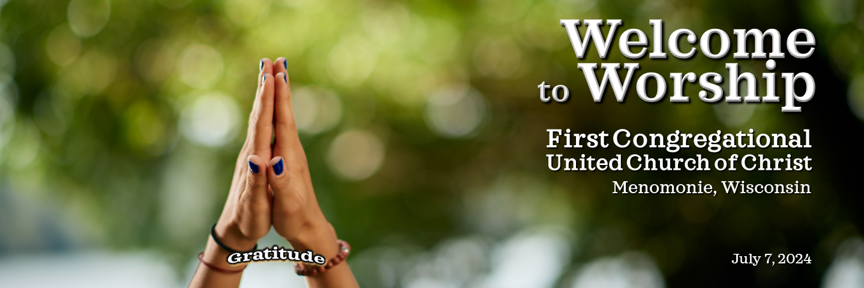

**Welcome and Announcements** Karen Miller

**Prelude/Candle Lighting “Air in d minor”** Oxana Khramova  
 (G. Handel)

**Ringing of the Bell**

**\*Call to Worship**  Karen Miller

Leader: Heavenly Creator, we invoke your holy presence.

**All: In your presence there is fullness of joy.**

Leader: You are the source of all that is good and righteous.

**All: You are the God of compassion, the God of all comfort.**

Leader: We come before you with hearts filled with anticipation

**All: Open our hearts to receive your word.**

**\*Opening Prayer** (in unison) Karen Miller

**When we see your sacred generosity, we become aware that we live in an infinite circle**

**of gratitude. We all are guests at a hospitable table around which gifts are passed and**

**received. We will not let anything opposed to love take over this table. Instead, we**

**choose to open our eyes to see grace and the gifts of life everywhere. In this choosing, we**

**will share gratitude in the world. We ask you to strengthen us in this resolve. Here,**

**now, and into the future. Around this table. Around the table of our nation. Around the**

**table of the earth.**

**Amen.**

**\*Opening Hymn “Morning Has Broken”** **Hymnal #469**

**Readings** Sandy Lindow

Genesis 1: 20-21

Psalm 100: 1-5

Matthew 5: 14-16

1 Corinthians 14:15

“*That Passeth All Understanding*” poem by Denise Levertov

**Special Music** **“Improvisations on Irish Tunes”** Isaiah May

(Traditional)

**Sermon** **“Practical Giving of Thanks”** Dennis Peters

**Transitional Music “Be Still and Know”** Oxana Khramova  
 (J.L. Bell)

**Prayers of the People** Karen Miller

**Lord’s Prayer**

**Our Father/Mother/Creator, who art in heaven, hallowed be thy name. Thy kingdom** **come, thy will be done on earth as it is in heaven. Give us this day our daily** **bread, and forgive us our debts as we forgive our debtors. And lead us not into temptation but deliver us from evil. For thine is the kingdom, and the power, and the glory forever.**

**Offertory “Ashokan Farewell”** Isaiah May

(Jay Ungar)

**\*Doxology**

**Praise God from whom all blessings flow;**

**Praise God all creatures here below;**

**Praise God above ye heavenly host;**

**Creator, Christ, and Holy Ghost. Amen.**

**\*Prayer of Dedication** (in unison) Karen Miller

**O Spirit of abundant blessings, we present our offerings as a symbol of gratitude for your abundant love and mercy. Everything we are and everything we have come from you. May we, in turn, learn to give you all we have. May these offerings today express our commitment and desire to serve your good world. What has freely come, we now let freely go. Amen.**

**\*Closing Hymn “This is my song/Finlandia”** **SoF #138**

**\*Benediction** Karen Miller

Leader:

Gracious God, you gather your people with love to bind our wounds, with hope to heal our hearts, with faith to clear our minds, with truth to set us free. We have been gathered by prayer, gathered by the Spirit, to mend the great circle. Now let us be about what must be done.

**All: Amen.**

**\*Sung Benediction** (unison)

God be with you till we meet again;

By their counsels' guide, uphold you;

With their sheep securely fold you;

God be with you till we meet again.

**Postlude** **“Growing in Faith”** Oxana Khramova  
 (G. DeMan)

***The flowers today are from Bill and June Grambo in memory of their parents,***

***William and Verna Grambo and Norman and Marjorie Shelliam.***

**Credits**

* The Call to Worship is from Bible Verses Now at <https://www.bibleversesnow.com>.
* The Opening Prayer was written by Diane Butler Bass, *A Thanksgiving Prayer* at <https://progressivechristianity.org/resource/a-thanksgiving-prayer/>. 2019.
* Prayers of the People and the Benediction are adapted from the meditations and writings of Steven Charleston, *Spirit Wheel* 2023. Prayers of the People include an adaptation of the *Prayer by St. Basil the Great*.
* Licenses purchased to reprint, podcast, and/or stream the music in this service obtained: ONELICENSE #A-715543. All rights reserved. CCLI Copyright License B 20989858

**Mission Statement of First Congregational United Church of Christ in Menomonie, WI**

We are called together:

To celebrate God’s presence.

To help each person to grow in his or her relationship with God;

To create a welcoming and supportive community of all God’s people, affirming the diversity of race, gender, age, sexual orientation, gender expression, and identity, social and economic status, and the differently abled;

To observe and share life’s passages and our faith traditions;

To reach out in love seeking justice and peace;

And to tell the old story of Jesus and His love.